MUHAMMAD NAIMATULLAH KHAN

21K-4540

SECTION 3K

QUESTION NO 1:

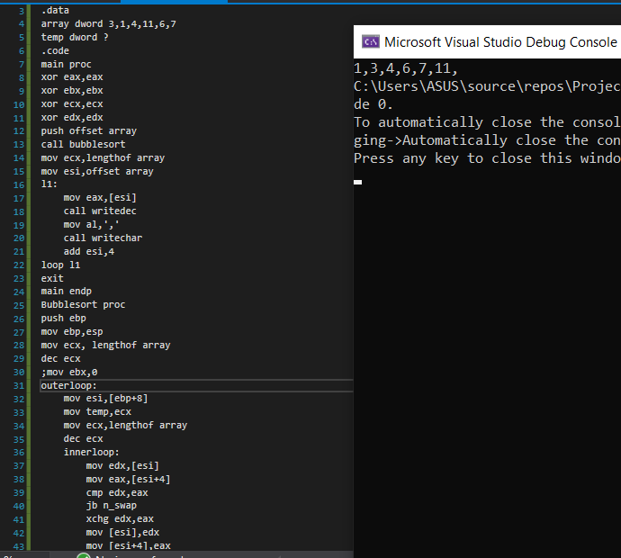

QUESTION NO 2:

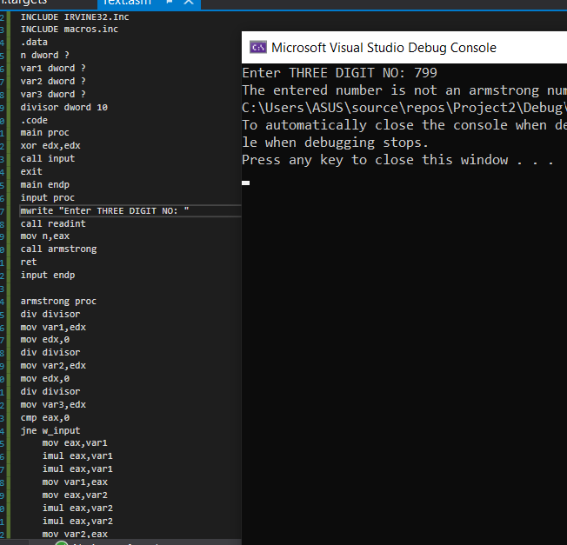

QUESTION NO 3:

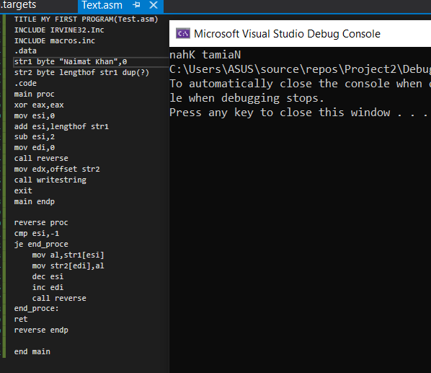

QUESTION NO 4:

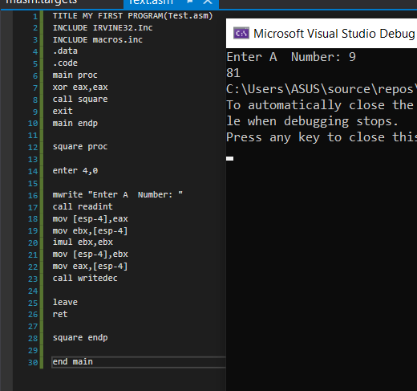

QUESTION NO 5:

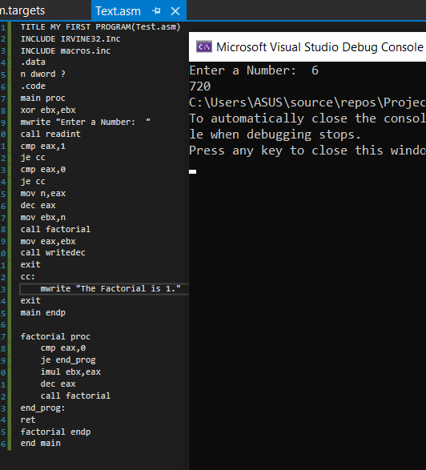

QUESTION NO 6:

